At the outset
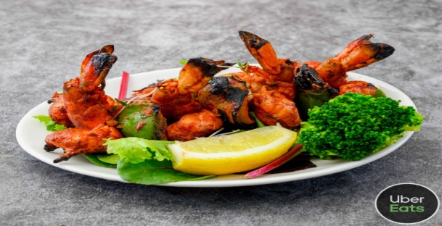

Spiced Broccoli & Pea Soup………………… …………………………….£4.95
A delicate coloured creamy soup. It has a mild spicy flavour created with a blend of greens.
King Prawn Butterfly……………………………………………………………£6.95
Large raw king prawns tossed in a blend of spices then deep fried to a crunchy coating
Spicy Mussels……………………………………………………………………...£8.95
Muscles steamed in acoconut and butter creamy sauce with white wine.
Samosa ( Meat/ Vegetable)………………………………………………..£4.95
Onion Bhaji…………………………………………………………………………£4.95
Seekh Kabab……………………………………………………………………….£4.95
Chicken or Lamb Tikka ……………………………………………………….£4.95
Chicken Chat ……..…………………………………………………………..….£5.50
Meridian Spice Mixed Platter( for one )…………………….…………£8.95
Chicken tikka, Lamb Tikka, Seekh Kabab, Veg Samosa
Tandoori Paneer Tikka …………..…………… …………………………….£6.95
Grilled Indian Cheese stir fried with capsicum and Onions, spiced with sweet chilli sauce
Salmon Tikka………………………………………………………..………..£6.95
Amritsari Fish………………………………………………………………….£6.95
Fish cubes lightly spiced and deep fried
Fried Chilli Prawns…………………………………………………………..£7.95
Spiced with chilli and garlic paste coated with sesame seeds and served with tamarind sauce.
King Prawn Puri………………………………………………………………….£8.95
Mango and Prawn Puri……………………………………………………….£7.95

Master creations
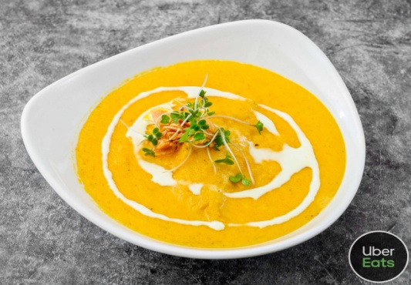
Chicken Tikka Butter Masala…………………………………..£12.95
Tender cubes of chicken breast cooked in butter & creamy sauce
Green Chilli Chicken…………………………………………………………..£10.95
Cubes of chicken fillet marinated in a blend of tamarind, coriander, green chillies, shallots & tomatoes - cooked in a thick spicy sauce
Chicken/ Lamb Chettinad…………………………………………………….£10.95
Chicken marinated in cumin seeds & black pepper cooked in spicy coconut sauce with onions, tamarind & cinnamon
Methi Murgh………………………………………………………………………£11.95
Chicken cooked with fresh fenugreek leaves & flavoured with fresh chillies, ginger & black cardamom
Chicken/ lamb Lazeez ………………………………………………………..£10.95
Chicken Marinated in a blend of different spices and herbs. A very Special Dish
Shaslick - E- Bahar Chicken /Lamb………………………………………..£11.95
Chicken tikka or Lamb Tikka Cooked with touch of garlic , green chillies served with a thick sauce . a sizzling dish.
Bombay Flame Chicken /Lamb……………………………………………..£10.95
A hot curry cooked with potato in special Naga Chilli
Chicken / Lamb Tikka Sizzling ( Hot) …………………………………£11.95
Served with ground coconut , green chilli, corriander in chef, special sauce.
Himalaya Chicken ( Contains Alcohol)………………………………...…£11.95
Mild and Creamy Chicken enhanced with one shot of Sambuca
Beef Buffad …………………………………………… ………….……£11.95
Cubes of braised beefsteak cooked slowly with a subtle combination of spices & coconut milk
Chilli Beef……………………………………….………………………..……..…..£11.95
Stewing beef marinated in a blend of fresh ginger & garlic cooked with a selection of ground spices & fresh chillies
Lamb/ Chicken Pasanda ………………………….……………….…...£12.95
Braised lamb fillets cooked in mild spices then simmered in a creamy yoghurt sauce
Chicken or Lamb Tikka Masala ..………………………………….….£12.95
Cooked in thick creamy sauce with ground coconut & almonds
Tandoori King Prawn Masala ……………………………………...£14.95
Cooked in thick creamy sauce with ground coconut & almonds

Meridian Signature Dishes
All signatures Dishes are Complete Meals
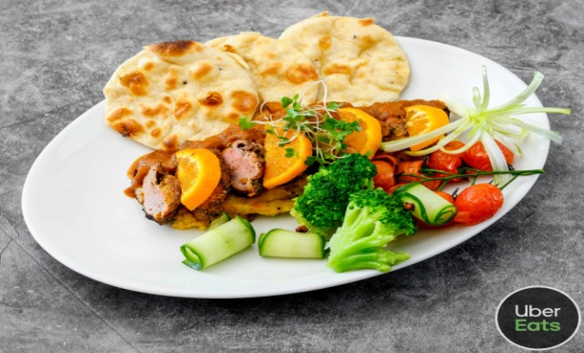
Tandoori Duck………………………………………………………….… £ 21.95
Duck breast cooked in a tandoor , served on a bed of mashed potatoes infused with curry leaves and glazed with red wine juice. Served with Pulao rice and a Nan bread.
Crab Masala………………………………………………………………….£20.95
Succulent crab meat cooked with mustard seeds, curry leaves, tomatoes and raw mango puree. Served in its own shell. Served with Nan, Coconut Rice and Mixed Veg. A true feast for fish Lovers.
Lamb Shank ……………………………………………………………..…..£20.95
Aromatic Lamb shank infused with star aniseed and rosemary. Cooked in rich wine and tomato sauce. Served with Pulao rice
Tandoori Lamb Chops…………………………………………………….£20.95
Lamb Chops marinated with herbs and spices and cooked in clay Oven, served with Mashed potatoes , red wine sauce and Nan bread and yellow lentils.
Grilled Sea bass ………………………………………………..…….£21.95
Pan fried sea bass cooked with mustard seeds , fresh curry leaves , ginger with coconut sauce in a abed of mashed potatoes . Served with Lemon rice , baby nan and Fresh mixed vegetables.
Grilled Wild Salmon …………………………………………………………… £21.95
Served with fresh baby spinach tossed with garlic and cheese. Platter Consist baby Nan , Asparagus and Broccoli.

Fish & shell fish
Goan Fish Curry……………………………………………………………………£11.95
Fish Fillet cooked in traditional Goan Spices
Salmon Hara Dhania…………………………………………………………….£12.95
Pan seared salmon steak prepared with red onions, crushed black peppercorns, poppy seeds & chopped coriander springs
Seafood Bhuna……………………………………………………………………..£13.95
An infusion of king scallops, squid, cube of fish fillet, tiger prawns cooked in our chef's speciality stock, a medium blend of bhuna spices & herbs
Fish Fry Masala Spicy Sizzling………………..…………………….…£12.95
Fish fillet marinated with light spices & delicate herbs, pan fried with mushrooms & peepers

Touch of the Tandoor( Clay Oven)
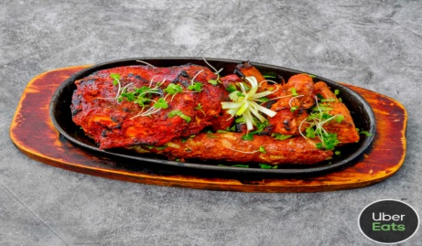
Chicken Tandoori (Half )……………………………………………………..£8.95
Half of spring chicken on the bone spiced & marinated overnight baked in the tandoor oven immediately before being served
Chicken Tikka ……….…………………………………………………………...£9.95
Chicken breast cubes marinated with yogurt and spices , grilled in tandoor.
Lamb Tikka ……….……………………………………………………………….£9.95
Lamb cubes marinated with yogurt and spices , grilled in tandoor.
Salmon Tikka ……….…………………………………………………………...£13.95
Cubes of Salmon fillets marinated in yoghurt with a selection of spices including cumin & carom seeds baked in the tandoor
Duck Shaslick……………………………………………………………………….£13.95
Chicken or Lamb Shashlik……………………………………………………...£11.95
Grilled chicken cubes with tomatoes, green peppers & onions
Tandoori King Prawn…………………………….………………………..……£13.95
King prawn marinated with herbs & spices, grilled in clay oven
Tandoori Mixed Grill…………………………………………………………...£13.95
Contains Tandoori grilled chicken, Chicken Tikka, boti kebab, Seekh kebab &Tandoori king prawns

Vegetarian Main Dishes
Seasonal Mixed Vegetables Stir Fried…………………………………£8.95
A special Bengali style dish prepared with an assortment of fresh vegetables
Khatte Mitti Gobi…………………………………………………………………£8.95
Cauliflower cooked with tamarind extract & honey
Paneer Shashliki Bahar……………………………………………………… £11.95
Cubes of Indian cheese grilled in the tandoor -----
Matar Malai Methi……………………………………………………………..£9.95
Peas cooked with Fenugreek leaves in creamy sauce
Panneer Kadahi Masala ………………………………………………..£11.95
Cubes of Indian cheese grilled in the tandoor and cooked in specially prepared sauce
Panneer Butter Masala ……………………………………………..…£11.95
Chilli Paneer Sweet &Sour…………………………………………….……..£9.95
Matar Paneer……………………………………………………………………….£9.95

Classic Curries
Prepared Individually in a rich , Spiced Curry Sauce in various strengths
Balti
Korma- prepared in a creamy sauce created by a blend of aromatic spices
Bhuna-Dry with Fenugreek Leaves
Do-piaza- with plenty of Onions
Dansak- Cooked with lentils-hot and sour
Vindaloo- very hot with potatoes
Madras- Fairly Hot and sour
Jalfrezi-Dry with sliced green chillies, capsicum and tomatoes
Pathia Cooked in athick hot and sour sauce
Curry - Medium and saucy
Rogan Josh- medium and spicy with tomatoes
Saag - Medium and spicy with spinach
Korai- with green peppers & Special blend of freshly ground spices
Chicken …..…………………………………........................................£9.95
Lamb ... …..…………………………………........................................£10.95
Prawn…………………………………………………………………………………£10.95
King Prawn………………………………………………………………………...£12.95
Shades of Basmati
Ingredients of all the following dishes are combined with basmati rice & pure butter ghee it is lightly spiced & has its taste enhanced with saffron, arranged in a platter served with a specially prepared Vegetable Curry
Meridian Spice Special Dum Biryani…………………………………..£13.95
Chicken Biryani ………………………………………………………………...£11.95
Lamb Biryani ……………………………………………………………………..£12.95
Vegetable Biryani ……………………………………………………………..£9.95
King Prawn Biryani………………………………………………………………£13.95
Stir Fries & Pulses
Mixed Vegetable Curry……………………………………………………... £4.95
Saag Bhaji Spinach fried with garlic & onions…………………………………… £4.95
Brinjal Bhaji Aubergine………………………………………………………..… £4.95
Bhindi Bhaji Fresh okra with dry mango powder………………….………….. £4.95
Saag Paneer Indian cheese with spinach & fenugreek…...................... £5.95
Saag Aloo Potato & spinach………………………………………………………. £4.95
Bombay Aloo Spiced potato in a medium sauce………………………………… £4.95
Aloo Gobi Potato & cauliflower …………………………………...……………. £4.95
Mushroom Bhaji……………………………………………………………… £4.95
Spicy Asparagus ………………………………...…….…..............……. £6.95
Cauliflower Bhaji…………………………………………………………….. £4.95
Chana Masala Spiced chickpeas…………………………………………………. £4.95
Tarka Daal Garlic tempered lentils………………………………………………… £5.95

Rice
Vegetable Rice……………………………………………………………………..£3.95
Special Fried Rice shrimps, egg, Onions ,peas………………………………..…£5.95
Garlic & Onion Rice……………………………………………………………….£3.95
Kashmiri Rice Prepared with an assortment of dried fruit………………....£3.95
Mushroom Rice…………………………………………………………………….£3.95
Coconut Rice.………………………………………………………………..£4.95
Keema Rice…………………………………………………………………………..£4.95
Lemon Rice…………………………………………………………………………..£3.95
Bengali Rice Spiced basmati rice with cashew nuts & hint of saffron ..…..£4.95
Egg Rice………………………………………………………………………………..£3.95
Pulao Rice…………………………………………………………………………..…£3.75
Plain Rice…………………………………………………………………………..…£3.75
Fries…………………………………………………………………………………..…£2.95
Bread
Leavened bread baked in the Tandoor
Plain Naan……………………………………………………………………………£2.95
Garlic Naan………………………………………………………………………….£3.95
Cheese Naan……………………………………………………………………… £3.95
Cheese & Keema Naan………………………………………….…………. £5.95
Bullet Naan Very Spicy Red Chilli &cheese…………………………….………… £3.95
Peshwari Naan ( Fruity) ……………………………………………... £3.95
Chilli & Coriander Nan………………………………………………………. £3.95
Keema Naan Stuffed with spicy minced meat Spicy.......................... £4.95
Tandoori Roti Medium Whole Meal Bread Baked in Tandoor………………. £2.95
Chappati Thin Whole Meal Bread……………………………………………….. £1.95
Puri Deep fried thin & puffy bread…………………………………………………. £2.50
Paratha Thick, layered bread fried in pure ghee…………………………………. £2.95
Stuffed Paratha…………………………………………………………………..£3.95

Sundries
Pappadom- Plain/Masala/Per Portion……..…………………………£0.90
Relish Tray…………………………………………………………………………£2.95
Contains: Mango chutney, Minty yoghurt sauce & Onion salad
Yoghurt Mint Sauce……………………………………………………………£0.75
Mango Chutney………………………………………………………………….£0.75
Mixed Pickle……………………………………………………………………….£0.75
Mixed Raita…………………………………………………………………………£2.50
Onions, coriander and cucumber mixed with fresh yogurt

Contain Nuts

